Journal Templates
1.25 inch

Title Times New Roman All Caps, 16 pt Left, Bold

Jinda Prommachod¹⁾ ,………………………….^{2)*} ,………………………….³⁾
¹⁾ Master Student Science Education. Faculty of Science and Technology.
Kanchanaburi Rajabhat University,
²⁾ Faculty of Science and Technology. Kanchanaburi Rajabhat University,
³⁾ Office of Primary Industries and Mines, Region 3 (Chiang Mai), Ministry
of Industry.
*Corresponding author e-mail:

ABSTRACT (Times New Roman 12 pt Bold)
Tab 7 alphabet …………………………………………………..………………………………
…………………………………………………………..…………………......…........…..
…………………………………………………………..…………………......…........…..
…………………………………………………..... (Times New Roman 12 pt Normal)
1.25 inch
1 inch
Keywords: AAAA, BBBB, CCCC (3-5 words) (Times New Roman 12 pt Normal)

Introduction (Times New Roman 12 pt Bold)
Tab 4 alphabet …………………………………………………..………………………………
…………………………………………………………..……………......………........…..
…………………………………………………………..……………......………........…..
…………………………………………………………..……………......………........…..
…………………………………………………..... (Times New Roman 12 pt Normal)

Objective
Tab 4 alphabet 1. ……………………………………………………….
2. ……………………………………………………….

Scope
Tab 4 alphabet …………………………………………………..………………………………
…………………………………………………………..……………......………........…..
…………………………………………………………..……………......………........…..

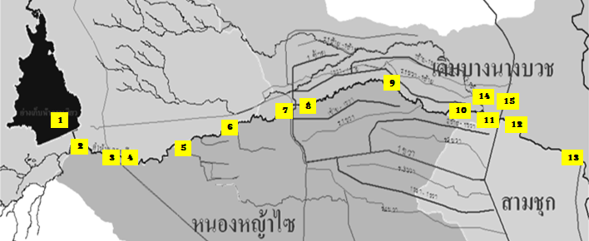

figure 1 aaaaaaaaaaaaaaaaaaaaaaaaaa
1 inch
Table 1 aaaaaaaaaaaaaaaaaaaaaaaaaaaaaaaaa
No. | Name of Place | Results |  | Details
No. | Name of Place | Latitude | Longitude | Details

Methodology
Tab 4 alphabet …………………………………………………..………………………………
…………………………………………………………..……………......………........…..
…………………………………………………………..……………......………........…..
Tab 4 alphabet Data Collection
Tab 4 alphabet …………………………………………………..………………………………
…………………………………………………………..……………......………........…..
…………………………………………………………..……………......………........…..
Tab 4 alphabet Data Analysis
Tab 4 alphabet …………………………………………………..………………………………
…………………………………………………………..……………......………........…..
…………………………………………………………..……………......………........…..

Results
Tab 4 alphabet …………………………………………………..………………………………
…………………………………………………………..……………......………........…..
…………………………………………………………..……………......………........…..
…………………………………………………………..……………......………........…..

Conclusion and Discussion
Tab 4 alphabet …………………………………………………..………………………………
…………………………………………………………..……………......………........…..
…………………………………………………………..……………......………........…..
…………………………………………………………..……………......………........…..

Suggestions
Tab 4 alphabet …………………………………………………..………………………………
…………………………………………………………..……………......………........…..
…………………………………………………………..……………......………........…..

References
Okuda, M., and Okuda, D. (1993). Star trek chronology: The history of the future.
(3rd ed.). New York: Pocket Books
Hwang, K., Jung, I. H., and Lee, A. M. (2022). Monitoring of MQTT-based Messaging Server. Webology, 19 (1), 4724-4735.
1 นิ้ว

